If you are working on a laptop/PC, you can make a document to type your answers onto. 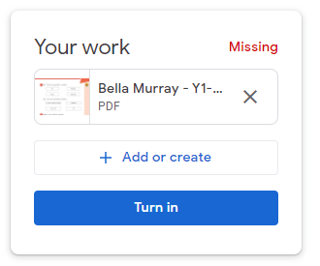
This will save automatically. Once you have finished your work, you can close the document.
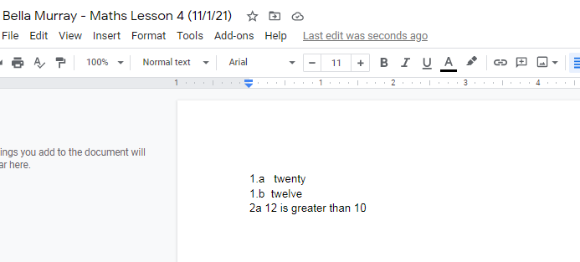
If you write on a piece of paper, you can take a picture and upload your work. Press the ‘Add or Create’ button and select the ‘file’ option to find the picture and upload. (You may need to connect the device you have taken the photograph on to do this)

If you are playing a game, you can take a screenshot to show how you get on. To do this, press the ‘PrtSc’ button on your keyboard, and then paste the screenshot into a GoogleDoc.
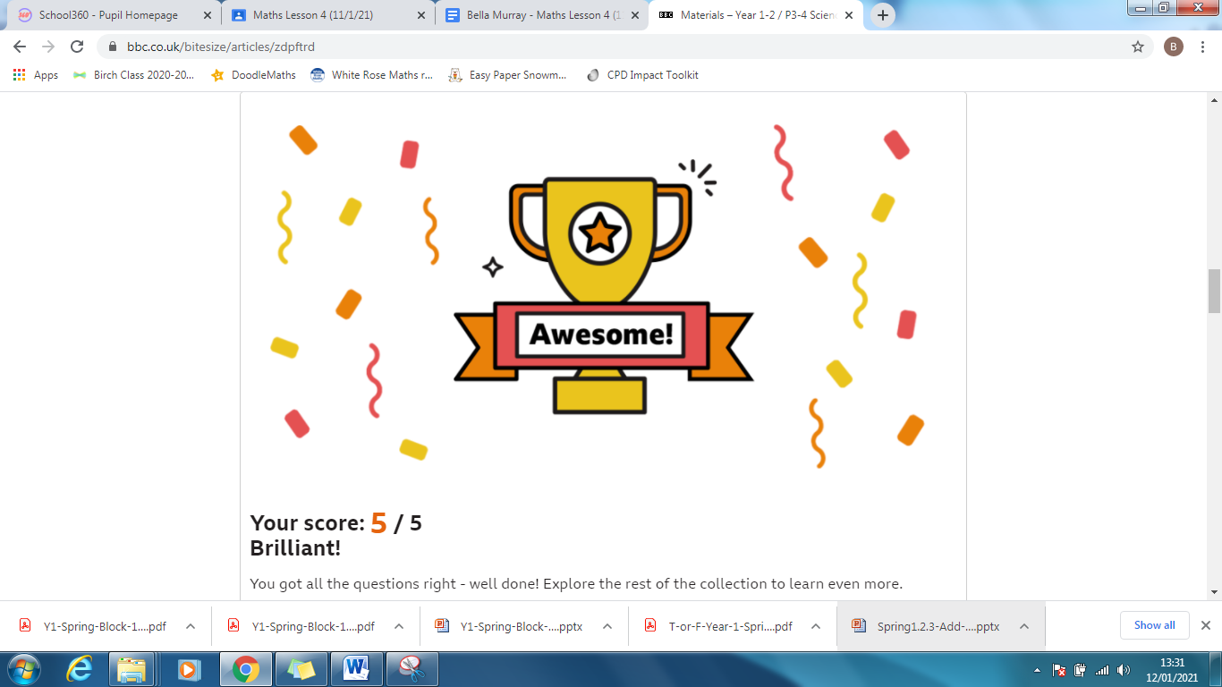
If you are working on a tablet, you can add a picture of any work you’ve done on paper by pressing ‘Add or Create’ and choose the ‘Take Photo or Video’ option. 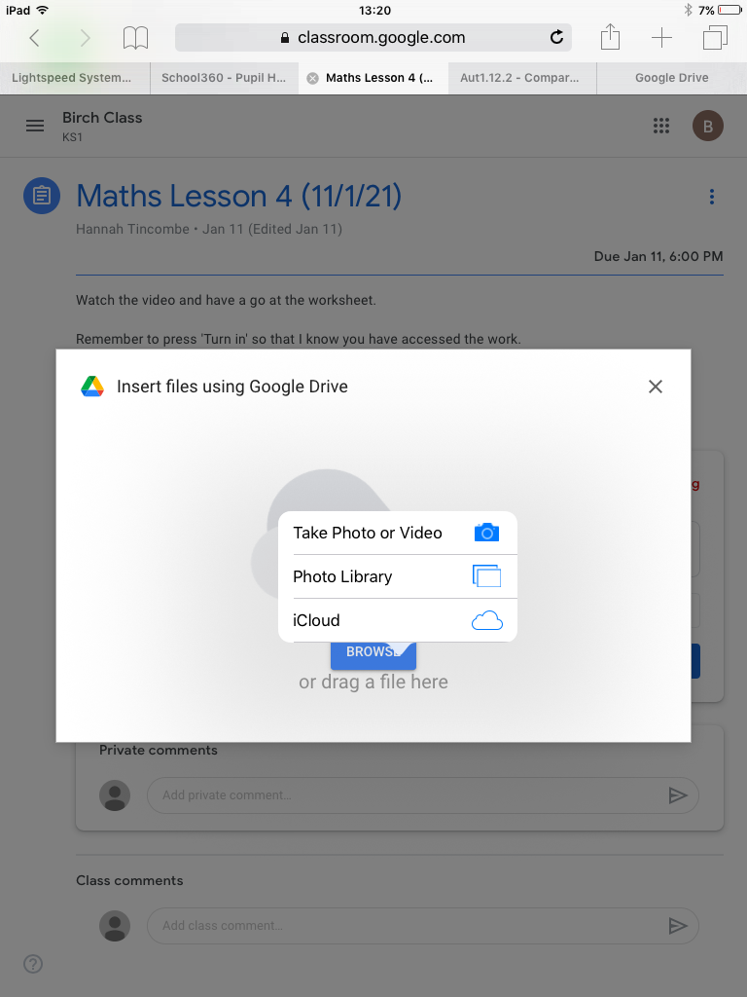
Once you are happy that your picture shows your work clearly, you can press ‘Use photo’ to attach it.
If you are playing a game, you can take a screenshot and attach it using the ‘Add or Create’ button.

However you decide to share your work, make sure you click 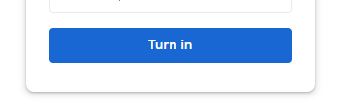
This will make sure your work gets submitted to your teacher.

