Otterburn Primary School

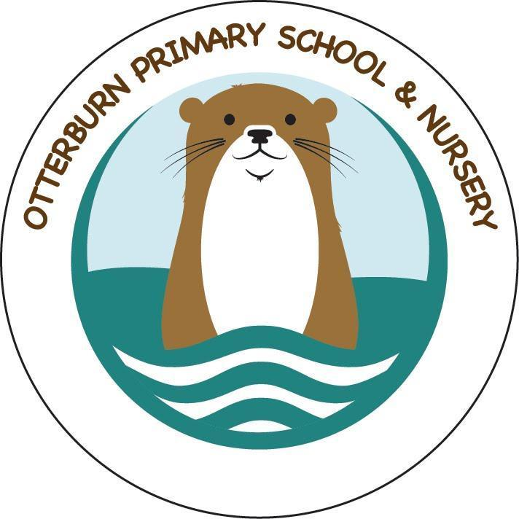

Forest School Food Hygiene Policy

Food Storage

* All perishable food must be stored in a cool box / bag and wrapped in appropriate packaging to avoid attracting insects and vermin.
* Food must never be left uncovered at any time.
* Raw meats must be stored separately to cooked meats in a chilled container.
* Make sure products are used within the ‘use by’ date.

Hygiene

* All cleaning products must be kept out of the reach of children.
* Hands must be cleaned before handling food and utensils.
* Do not handle food items if suffering from colds or similar infections.
* Cover all cuts and grazes in the appropriate manner.
* Clean all food utensils and place in storage.

Water

* All water provided By Forest School must be fresh and suitable for drinking.

Packed lunches

* Children are only permitted to eat at designated times.
* All children coming to Forest School must have a dry place in which to store their lunch bags.
* Food must be stored in suitable containers that keep the food under the correct conditions for eating at a later time.
* All rubbish from packed lunches must be taken away by the participant.

Disposal of waste

* All unused food stuffs and packaging must be disposed of appropriately.

Updated November 2024